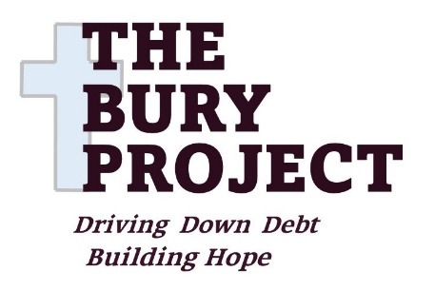 Thank you so much for being willing to donate.
Gift Aid / Standing Order
Your gifts will help to change lives for the better.
Your Details:
- Title *: Full Name *:
- Address * :
- Post Code * : * Reqiored information.
How may we contact you? By Phone / text Tel. …….……………….……
By post ……. Yes / No By e-mail address …………..………………………….
If you pay tax and agree to Gift Aid we can reclaim 25% of your donation from the tax you pay each year. That is an extra £2.50 for every £10 you give. Email us for clarification.
Gift Aid Declaration.
I want to Gift Aid my donation and any donations I will make in future and have made in the past four years (or since ……………………………..…..(date)) to The Bury Project (Charity Number 1183543). I am a UK taxpayer and understand that if I pay less Income Tax and/or Capital Gains Tax than the amount of Gift Aid claimed on all my charitable donations in that tax year, then it is my responsibility to repay the difference.

Signature: ……………………..……...………… Date: ……......………………..
Standing Order.
To set up a standing order please contact your bank or go online to set up a regular payment each month (or other period) to The Bury Project. Our bank account is with the Cooperative Bank Sort code: 08-92-99 Account No. 65872723
Please let us know if your details change (change of name or contact details) or if you no longer pay sufficient tax to claim gift aid.
Please send your completed form to us, in person, by post, or by email.
Website: http://theburyproject.org.uk Email: information@theburyproject.org.uk
Address: The Bury Project, C/O Bolton Road Methodist Church, Bolton Road, Bury, BL8 2NZ

